**Student:** Oleksandr Romanchenko

**ID:** 83459

Starting this task with conclusion about best model made at the end of previous one:

Building models and getting effects from them

Models without spatial autoregression:

SLX

According to p-values all types of effect are significant, Indirect is the weakest one.

SDEM

Here, we can see that indirect effect is not significant on the 95% confidence interval, its coefficient proves it (0.1822245). Other effects are significant.

Models with spatial autoregression:

SAR

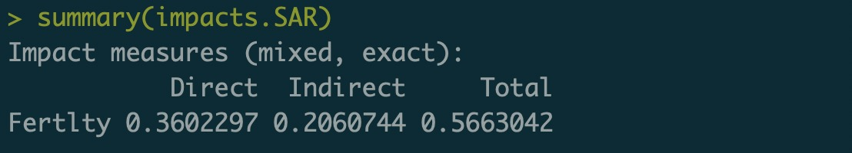

In this model Direct effect is stronger than Indirect one.

Confidence intervals:

SARAR



Here it’s vice versa. Indirect effect stronger than Direct one.

Confidence intervals:

SDM

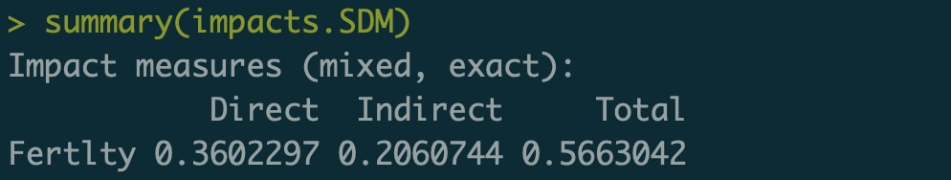

The same situation as in SAR model. Direct stronger than Indirect one.

Confidence intervals:

In all models except SDEM and SDM Indirect effect is significant so we can conclude that on average it is significant.

